**Top Strategies to Win Big on Online Slots**  
  
Online slots have revolutionized just how people enjoy gambling and entertainment, offering a combined simplicity and excitement that interests players of skill levels. Unlike traditional slot machine games, which are normally found in physical casinos, online slots are accessible from anywhere, allowing players to be a part of their best games from the comfort of their properties or on the go. These games are meant to captivate with stunning visuals, immersive soundtracks, and fascinating themes, ranging from ancient mythology and adventure to modern pop culture and fantasy worlds. The convenience of online slots, combined making use of their diverse offerings, means they are a trendy choice for casual players and gamblers alike [judisgp](http://judisgp.com/" \t "_blank).

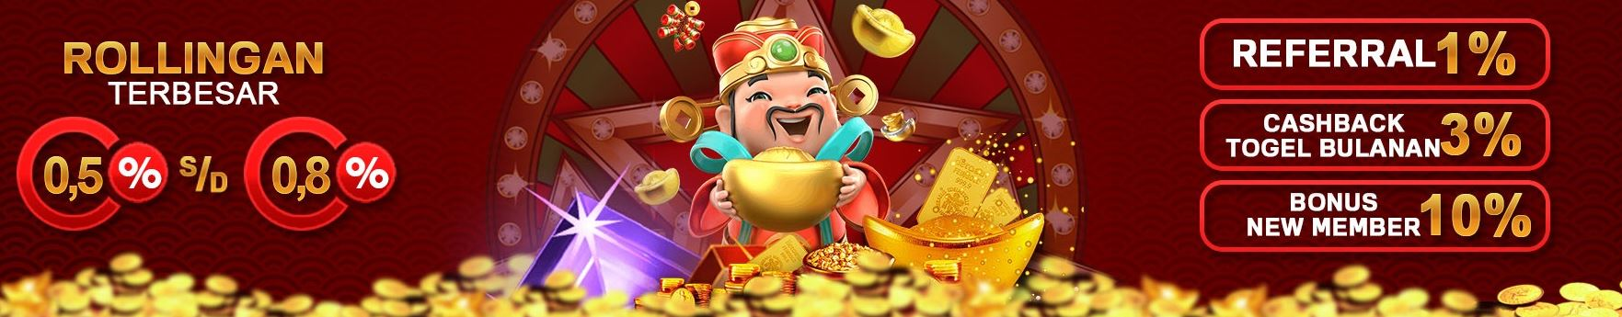

Online slots boast a number of features that improve gaming experience. The basic mechanics involve spinning reels with symbols that align in winning combinations, but modern online slots go beyond this easy concept. They include features like wild symbols, scatter symbols, free spins, and bonus rounds, which all increase the likelihood of winning and add excitement to your game. Some online slots incorporate progressive jackpots, where the prize pool grows with every bet placed by players across the platform, offering life-changing payouts to lucky winners. Additionally, innovations like cascading reels, multipliers, and themed mini-games keep gameplay dynamic and engaging.

While online slots are largely games of chance, players can adopt strategies to improve their experience and potentially grow their winnings. Understanding the game's RTP (Return to Player) percentage and volatility is crucial. Slots with higher RTPs typically offer better long-term payouts, while volatility determines how often and dimensions of winnings. Low-volatility slots provide frequent but smaller wins, whereas high-volatility slots offer more uncommon but larger payouts. Setting an allowance and managing your bankroll effectively helps to ensure that gaming remains enjoyable as well as doesn't result in overspending. Profiting from bonuses and promotions, including free spins and deposit matches, can also extend playtime and increase winning opportunities.

The way forward for online slots is poised to become much more innovative, with advancements in technology leading the way. Virtual reality (VR) and augmented reality (AR) are set to transform online slots, creating immersive environments where players feel like they're in an actual casino. Gamification is the one other trend, integrating challenges, achievements, and interactive elements to have the games more engaging. Blockchain technology and cryptocurrencies will also be shaping the, offering secure, transparent, and fast transactions. As developers carry on and push the boundaries of creativity and technology, online slots are evolving into an advanced sort of entertainment that mixes fun, innovation, and potential rewards.

In the end, online slots are more than solely games of chance; they certainly are a dynamic sort of entertainment that has something for everyone. Utilizing their engaging themes, exciting features, and potential for big wins, they are getting to be a cornerstone of online gaming. As technology continues to succeed, the joy of online slots promises even bigger thrills and innovations for players about the globe.